

|  |  |
| --- | --- |
|  | **Shutterfly Google Drive Migration**  Functional Specs  Prepared For  Shutterfly  Prepared By  Rabiah Memon, Sr. Solutions Architect  Version 1.0 |

# Revision History

|  |  |  |
| --- | --- | --- |
| Date | Author | Description |
| 5/9/2022 | Rabiah Memon | Draft 1 complete |
| 5/10/2022 | Rabiah Memon | Draft 1 review with client |
|  |  |  |
|  |  |  |
|  |  |  |
|  |  |  |
|  |  |  |

Table of Contents

Revision History 2

Document Purpose 4

Project Overview 4

Assets 5

Build Details 5

Global navigation menu 5

Site Architecture 6

Life Touch Hub 6

Operations Hub 6

Photography Hub 7

Sales Hub 8

Us Field Hub 8

Site Permissions and Security 14

Permission Groups 14

Permission Levels 15

General rules of site permission 15

SITE COLLECTION ADMINISTRATORS GROUP 15

Lifetouch Site Build Decision Tracker 15

Roadmap Items 16

# Document Purpose

Shutterfly, LLC. is an American photography, photography products, and image sharing company, headquartered in Redwood City, California. Shutterfly has contacted Affirma to help with migrating the data from Google Drive into SharePoint and OneDrive, as well as building a replacement for the Google Site iHub in SharePoint Online.

The Affirma project team has gathered requirements and will design and build a SharePoint site to replace the iHub portal for Shutterfly team. This document outlines the high level functional specifications for the new Lifetouch Host Photography site that will be built on SharePoint Online. The specifications in this document are not final, and are subject to change during the implementation phase.

Included specifications are high level specifications only, detailed build specifications will be added after the designs have been finalized, and will added to this document during the implementation and deployment phases. Additionally, an admin/user guide will be provided after the implementation has been completed that would serve as a “How to” guide for admins to manage sites, webparts, and content. A detailed project plan will also be created when the implementation phase begins to list out specific tasks that will need to be completed to take project to competition.

# Project Overview

Affirma team will collaborate with the communications and IT team from Shutterfly to design, develop, and implement a SharePoint site to replace iHub for Lifetouch.

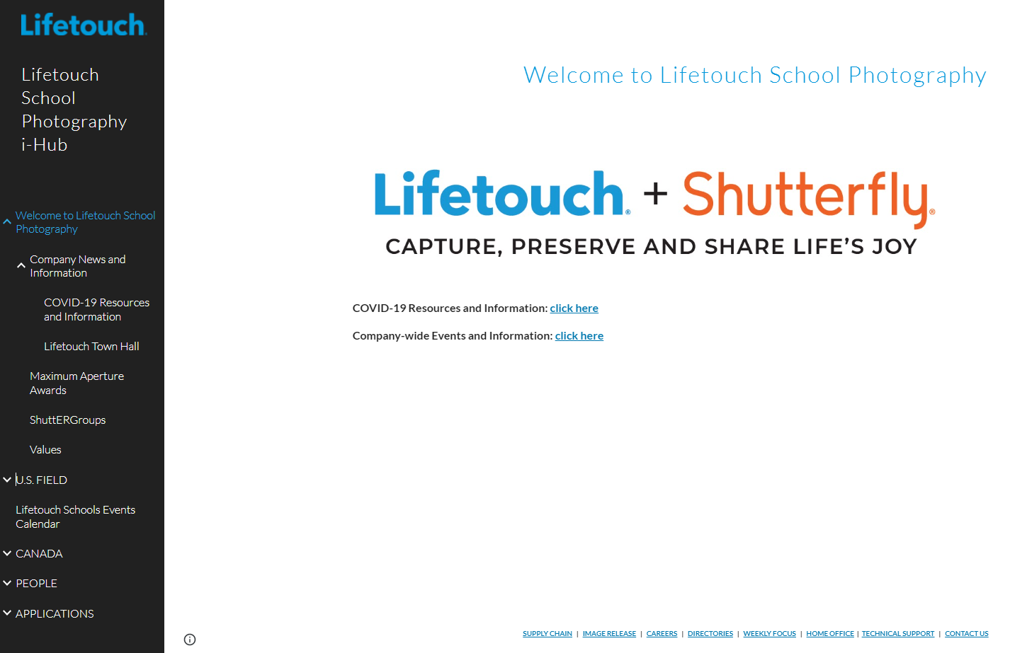

Figure 1 Screenshot of the current Lifetouch home page

Current site allows users to navigate and access content from the left navigation bar that is organized in a tree structure. Affirma team has proposed an Information Architecture that categorizes the data in pages, lists, and libraries that are hosted on a SharePoint Online Hub.

SharePoint Modern look and feel will be utilized for this effort.

## Assets

1. Proposed design layout comps can be found [here](https://teams.microsoft.com/_#/files/General?threadId=19:RzU-5qvSvuevz8X8211a1S6q8iDiPltY91GyU6gqDTE1@thread.tacv2&ctx=channel&rootfolder=%252Fsites%252FAffirmaDataAssessment%252FShared%2520Documents%252FGeneral%252FSharePoint%2520Design).

# Build Details

## Global navigation menu

The navigation to be used globally will be a Mega Menu using Modern SharePoint Hub site. Each other site collections will be associated to the root hub site which will inherit the top navigation bar as well as the custom theming.

## Site Architecture

At the time of writing this documentation, the following was setup has been recommended based on the design and Information architecture discovery, and is subject to change during implementation phase, depending on the additional Information Architecture restructuring, as well as content creation.

### Life Touch Hub

A Lifetouch hub will be created that will serve as the parent hub. This hub will then be associated with child hubs for Operations, Photography, Sales, US Field, Canada, People, and Applications.

Note: This hub architecture is scalable and new sites can be added as needed to share themes and navigation structure.

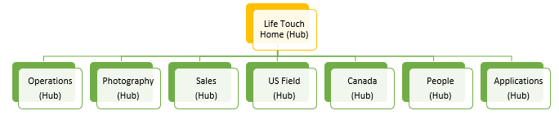

Figure 2: High level structure of the Lifetouch Parent Hub and Associated Member Hubs

Lifetouch Hub will include the following Data Sources:

* Document Library - to hold documents and assets.
* List – to store hyperlinks to YouTube videos.
* Site Pages to host content:
  + Landing Page
  + [Company News and Information](https://shutterfly.sharepoint.com/sites/News/SitePages/Schools-Weekly-Messages.aspx)
  + [Covid 19 Resources and Information](https://shutterfly.sharepoint.com/COVID19%20Resources/Forms/AllItems.aspx)
  + [Lifetouch Town Hall](https://shutterfly.sharepoint.com/SitePages/Lifetouch-Town-Halls.aspx)
  + [Maximum Aperture Awards](https://shutterfly.sharepoint.com/sites/HR/SitePages/Maximum-Aperture.aspx)
  + [ShutterGroups](https://shutterfly.sharepoint.com/sites/corporateresources/SitePages/shuttERGroups.aspx)
  + [Values](https://shutterfly.sharepoint.com/sites/HR/SFLYValues/SitePages/Shutterfly%20Values.aspx)
  + PCI Compliance

### Operations Hub

Operations Hub is a child hub that is attached to the main Lifetouch Hub and shares navigation from the home site.

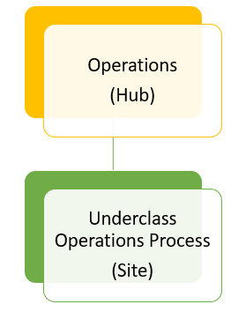

Figure 3: Architecture of the Operations Hub and Member Site

Operations hub will include the following Data Sources:

* Site:
  + Underclass Operations Process
* Document Library - to hold documents and assets.
* Site Pages to host content:
  + Landing Page
  + Commencements
  + Sports
  + Operations Training
  + Webcast Recordings and Related Documents

Note: For data sources for individual sites that are attached to the Operations Hub, refer to the Shutterfly iHub Information Architecture excel file listed [here](https://shutterfly.sharepoint.com/sites/AffirmaDataAssessment/Shared%20Documents/General/Affirma%20Documentation?csf=1&web=1&e=BTvlOw&OR=Teams-HL&CT=1652197438905&cid=9c73ec78-ed33-42b4-8e39-35f3643b3092).

### Photography Hub

Photography Hub is a child hub that is attached to the main Lifetouch Hub and shares navigation from the home site.

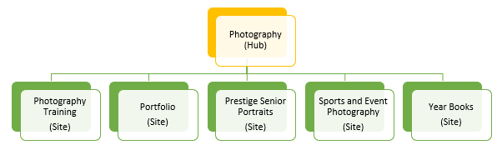

Figure 4: Architecture of the Photography Hub and Member Sites

Photography hub will include the following Data Sources:

* Sites Attached to the hub
  + Photography Training
  + Portfolio
  + Prestige Senior Portraits
  + Sports and Event Photography
  + Year Books
* Document Library - to hold documents and assets.
* Site Pages to host content:
  + Landing Page
  + Commencements
  + Sports
  + Operations Training
  + Webcast Recordings and Related Documents

Note: For data sources for individual sites that are attached to the Photography Hub, refer to the Shutterfly iHub Information Architecture excel file listed [here](https://shutterfly.sharepoint.com/sites/AffirmaDataAssessment/Shared%20Documents/General/Affirma%20Documentation?csf=1&web=1&e=BTvlOw&OR=Teams-HL&CT=1652197438905&cid=9c73ec78-ed33-42b4-8e39-35f3643b3092).

### Sales Hub

Sales Hub is a child hub that is attached to the main Lifetouch Hub and shares navigation from the home site. Sales hub will include the following Data Sources:

* Document Library - to hold documents and assets.
* Site Pages to host content:
  + Retention Resources
  + Sales Management Resources
  + Training

### Us Field Hub

US Field Hub is a child hub that is attached to the main Lifetouch Hub and shares navigation from the home site.

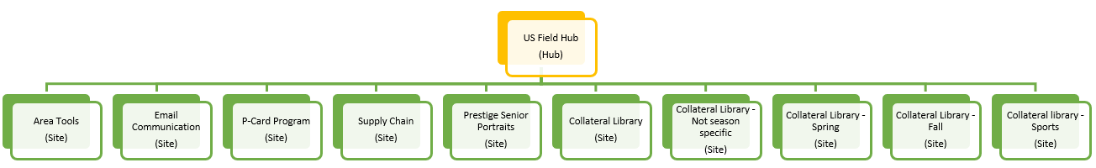

Figure 5: Architecture of the US Field Hub and Member Sites

US Field hub will include the following Data Sources:

* Sites:
  + Area Tools
  + Email Communication
  + P-Card Program
  + [Supply Chain](https://shutterfly.sharepoint.com/sites/lsi-supplychain/Pages/_Supply-Chain-Perferred-Travel-and-Supply-Programs.aspx)
  + Prestige Senior Portraits
  + Collateral Library
  + Collateral Library – Not Season Specific
  + Collateral Library – Spring
  + Collateral Library – Fall
  + Collateral Library – Sports
* Document Library - to hold documents and assets.
* Site Pages to host content:
  + Retention Resources
  + Sales Management Resources
  + Training

Note: For data sources for individual sites that are attached to the US Field Hub, refer to the Shutterfly iHub Information Architecture excel file listed [here](https://shutterfly.sharepoint.com/sites/AffirmaDataAssessment/Shared%20Documents/General/Affirma%20Documentation?csf=1&web=1&e=BTvlOw&OR=Teams-HL&CT=1652197438905&cid=9c73ec78-ed33-42b4-8e39-35f3643b3092).

Canada Hub

Canada Hub is a child hub that is attached to the main Lifetouch Hub and shares navigation from the home site.

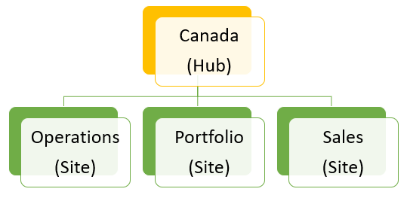

Figure 6: Architecture of the Canada Hub and Member Sites

Canada hub will include the following Data Sources:

* Sites
  + Operations
  + Portfolio
  + Sales
* Document Library - to hold documents and assets.
* Site Pages to host content:
  + Canada Landing Page
  + Area Tools
  + PCI Compliance

Note: For data sources for individual sites that are attached to the US Field Hub, refer to the Shutterfly iHub Information Architecture excel file listed [here](https://shutterfly.sharepoint.com/sites/AffirmaDataAssessment/Shared%20Documents/General/Affirma%20Documentation?csf=1&web=1&e=BTvlOw&OR=Teams-HL&CT=1652197438905&cid=9c73ec78-ed33-42b4-8e39-35f3643b3092).

People/HR Hub

People/HR Hub is a child hub that is attached to the main Lifetouch Hub and shares navigation from the home site.

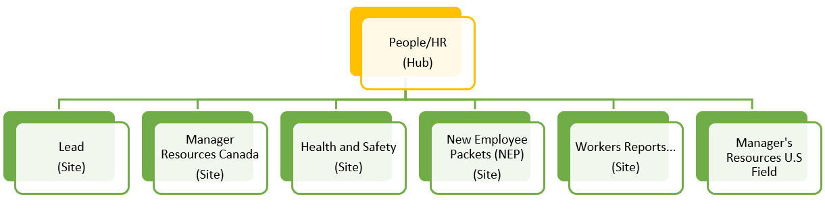

Figure 7: Architecture of the People/HR Hub and Member Sites

People/HR hub will include the following Data Sources:

* Sites:
  + Lead
  + Manager Resources Canada
  + Health and Safety
  + New Employee Packets (NEP)
  + Worker's Reports of Injury or Occupational Disease
  + Manager's Resources U.S. Field
* Document Library - to hold documents and assets.
* List - Careers
* Site Pages to host content:
  + People/HR Landing Page
  + Safety and Work Related Liability
  + [Shutterfly Employee Hardship Fund](https://shutterfly.sharepoint.com/sites/HR/SitePages/Shutterfly-Employee-Hardship-Fund.aspx)

Applications Hub

Applications Hub is a child hub that is attached to the main Lifetouch Hub and shares navigation from the home site.

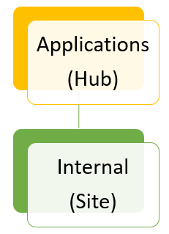

Figure 8: Architecture of the Applications hub and Member Sites

Applications hub will include the following Data Sources:

* Sites:
  + Internal
* Document Library - to hold documents and assets.
* Site Pages to host content:
  + Applications Landing Page
  + Canada External Applications
  + Canada Internal Applications
  + External (e-Commerce)

**Site Design**

Lifetouch Host Photography site is a content and multimedia rich website that has a heavy focus on user interface. Goal is to organize content in a way that allows visitors to easily find resources that they are looking for.

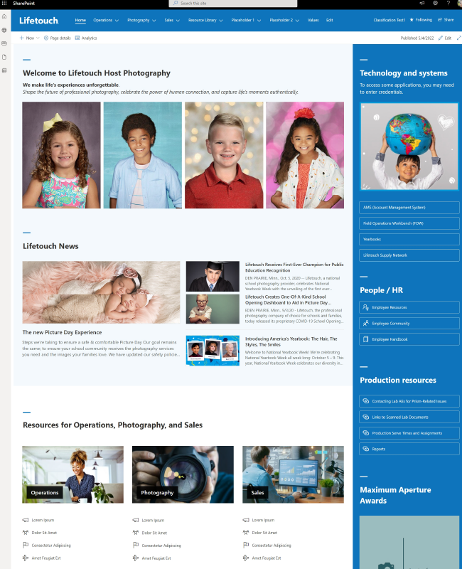

Figure 9: Screenshot of the newly designed Lifetouch Photography SharePoint Site

**Navigation**

Hub navigation from the parent hub will be inherited by all member hubs and sites. Each site will also retain a navigation for its own content, including but not limited to: pages, document libraries, lists, external and internal links.

**Themes**

Custom theme will be created by Affirma team that will be easily applied to any site that need to join the Lifetouch Hub.

**Page Templates**

Page templates will be created for each page that has been designed by Affirma’s creative team. This will allow users to quickly create pages using the template and add content.

**Footer**

Affirma team has designed an out of the box footer for Lifetouch SharePoint Site. Shutterfly team is currently having internal discussions around whether or not they would like to utilize the footer.

**Out of the Box Web Parts**

Following webparts have been identified by Affirma team that will be applied on different landing pages:

* Text Webpart
  + To add headers and content throughout the page.
* News Webpart
  + To display the most recent news articles that are published on the hub.
    - This can be filtered to include the news on just the main hub or throughout multiple member sites that are part of the hub.
* Image Gallery
  + To display images in an organized fashion on the hub and member sites.
* Quick links
  + Most frequently used resources on the site.
* Instagram Feed
  + To allow Lifetouch Instagram to be displayed on the home page.
* Microsoft Forms
  + To allow Shutterfly team to quickly configure surveys.

**Custom Webparts**

Shutterfly team has identified a need for a custom event webpart that allows users to quickly add events to the calendar, without having to download the ICS File.

Our Approach

Shutterfly team has approved the design for the look and feel of the event webpart.

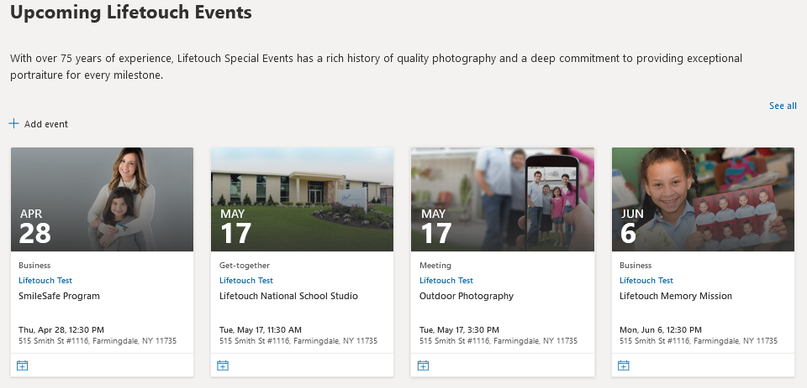

Figure 10: Screenshot of the Events Webpart as Designed by Affirma Team

The calendar webpart needs to have a functionality that allows users to quickly add events to their calendars. Affirma team has completed a proof of concept for this idea to evaluate the feasibility and challenges, and will brief Shutterfly team with the findings and recommendations.

Site Permissions and Security

Below are some general aspects for permissions based in SharePoint environments.

## Permission Groups

These default groups have established permission levels and can easily be utilized with few modifications. Below is a table that describes the default permission groups.

|  |  |  |
| --- | --- | --- |
| Group name | Permission level | Description |
| Visitors | Read | Use this group to grant people Read permissions to the SharePoint site. |
| Members | Edit | Use this group to grant people Edit permissions to the SharePoint site. |
| Owners | Full Control | Use this group to grant people Full Control permissions to the SharePoint site. |

## Permission Levels

Permission level controls access to the site and site components and the ability of users to perform or not perform tasks. By default, here are the permission levels that are available:

* **Read:** Includes permissions that enable users to view items on the site pages.
* **Contribute:** Includes permissions that enable users to add or change items on the site pages or in lists and document libraries.
* **Full Control:** Includes all permissions.

## General rules of site permission

* Break permission inheritance as infrequently as possible.
* Use groups based on folder membership to assign permissions.
* Assign permissions at the highest possible level.

## SITE COLLECTION ADMINISTRATORS GROUP

The site collection administrators have overall control over the SharePoint environment and have access to all content in the site collection. Ensure that the users listed have the proper credentials to manage the portal and are properly NDA’d to protect confidential information.

Lifetouch Site Build Decision Tracker

This section will document decisions that will be taken throughout the implementation.

|  |  |  |  |
| --- | --- | --- | --- |
| **Decision** | **Status** | **Approved By**  **(Shutterfly Stakeholder)** | **Date** |
| Finalize Designs | Pending | Pending |  |
| Finalize Site Access Permissions   * Identify “groups” that will need to have the following access:   + Read Only   + Edit   + Full Control | Pending | Pending |  |
| Identify Site Collection Administrator | Pending | Rahul, Monique, Becca and Pam | 05/23/2022 |
| Finalize Color/Branding | Pending | Existing Colors – Approved | 05/23/2022 |
| Footer (Yay/Nay) | Pending | Edit – Omit Navigation. Keep other three | 05/23/2022 |
| Approve Site Architecture | Pending | Refer to information in this document |  |
| Finalize Content and Information Architecture | Pending | Refer to information in this document |  |
| Finalize Navigation Structure and Elements | Pending | Refer to information in this document |  |
| Finalize Site Name/URL | Pending | Site Name: Lifetouch  URL: https://shutterfly.sharepoint.com/sites/Lifetouch | 05/23/2022 |
| Approve Metadata for SharePoint Lists and Libraries | Pending | Refer to information in this document |  |
| Approve sorting for content in SharePoint Libraries | Pending | Refer to information in this document |  |
| Identify users for UAT (User acceptance testing) | Pending | Identify via RASCI |  |

Roadmap Items

Throughout the course of the implementation phase, there maybe additional tasks, recommendations, or requirements that are identified as wish-list items that maybe out of scope for this project. Once those items are identified, they will be documented in this section as a future roadmap item.